Solution Architecture: HematoVision -

Advanced Blood Cell Classification

Date | 10 January 2026
Team ID | LTVIP2026TMIDS38170
Project Name | Hematovision: advanced blood cell classification using transfer learning
Maximum Marks | 4 marks

Introduction
This document outlines the solution architecture for HematoVision, an AI-powered system designed for the accurate and efficient classification of blood cells. The architecture leverages a combination of deep learning models and a user-friendly web application to provide a robust and scalable solution for pathologists and healthcare professionals.

High-Level Architecture Overview
The HematoVision system follows a typical client-server architecture, where a web-based frontend interacts with a Python-based backend that hosts the machine learning model.
The core components include:

- Client-Side (Web Browser): User interface for interacting with the system.

- Web Application Backend (Flask): Handles user requests, manages image uploads, and orchestrates interactions with the machine learning model.

- Machine Learning Model (TensorFlow/Keras): The trained deep learning model responsible for blood cell classification.

- Storage: For temporary storage of uploaded images.

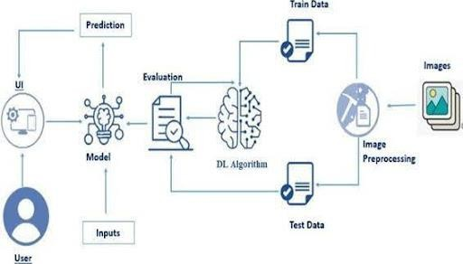

Detailed Component Breakdown

Client-Side (Frontend)

    - Technology: HTML, CSS, JavaScript (standard web technologies).

    - Purpose: Provides the graphical user interface (GUI) for users to interact with the HematoVision system.

Key Functions:

    - Image Upload: Allows users to select and upload blood cell images (e.g., home.html ).

    - Display Results: Presents the classification prediction and the uploaded image (e.g., result.html ).

    - User Feedback: Potentially provides visual cues for upload progress or errors.

Web Application Backend (Flask)

    - Technology: Python, Flask framework ( app.py ).

    - Purpose: Acts as the central hub, receiving requests from the frontend, processing them, and returning responses. It integrates the machine learning model.

Key Functions:


    - API Endpoints: Defines routes for image upload ( /predict ) and serving web pages ( / ).

    - Image Handling: Receives uploaded image files, saves them temporarily, and prepares them for model inference.

    - Model Inference Orchestration: Loads the pre-trained blood_cell.h5 model and passes the processed image data to it for classification.

    - Result Processing: Receives the prediction from the model and formats it for display on the frontend.

    - Error Handling: Manages invalid file types or other processing errors.

    - Templating: Renders HTML templates ( home.html , result.html ) to serve dynamic content to the user.

Machine Learning Model

    - Technology: TensorFlow, Keras, MobileNetV2 ( model.ipynb , blood_cell.h5 ).

    - Purpose: The core intelligence of the system, responsible for accurately classifying blood cells.

Key Functions:

    - Image Classification: Takes a preprocessed blood cell image as input and outputs a probability distribution over the four blood cell classes (Eosinophil, Lymphocyte, Monocyte, Neutrophil).

    - Feature Extraction: The pre-trained MobileNetV2 acts as a powerful feature extractor.

    - Prediction: Provides the final predicted class based on the model's output.

    - Training Details (from model.ipynb and README_HematoVision.md ):

    - Architecture: MobileNetV2 (pre-trained) with custom classification layers.

    - Dataset: 12,500 augmented blood cell images from Kaggle.

    - Training: 5 epochs (as per README), Adam optimizer, categorical cross-entropy loss.

    - Accuracy: Approximately 85.3% validation accuracy.

    - Model Persistence: The trained model is saved as blood_cell.h5 for deployment.

Storage

    - Technology: Local filesystem.

    - Purpose: Temporarily stores uploaded images before they are processed by the model.

Key Functions:

    - Temporary Uploads: The static/uploads/ directory is used to store images uploaded by users via the web interface.

    - File Management: Images are typically deleted after processing or after a certain period to manage storage space.

Data Flow and Interactions
- User Interaction: A user accesses the HematoVision web application through their browser, which loads home.html from the Flask backend.
- Image Upload: The user selects a blood cell image and uploads it via the web form. This HTTP POST request is sent to the /predict endpoint of the Flask application.

Backend Processing:

  - The Flask application ( app.py ) receives the uploaded image.

  - It saves the image temporarily in the static/uploads/ directory.

  - The image is then preprocessed (resized, normalized) to match the input requirements of the MobileNetV2 model.

  - The preprocessed image is passed to the loaded blood_cell.h5 model for inference.
- Model Prediction: The MobileNetV2 model performs the classification and returns the predicted blood cell type.

Result Display:

  - The Flask application receives the prediction from the model.

  - It then renders the result.html template, passing the prediction and the path to the uploaded image.

  - The result.html page is sent back to the user's browser, displaying the classification outcome.
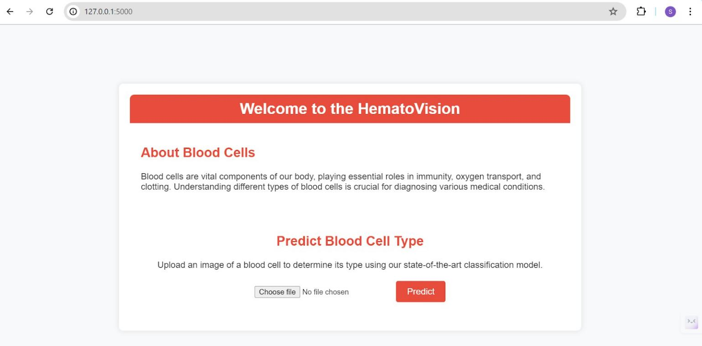

Deployment Considerations
- Containerization: The application can be containerized using Docker for consistent deployment across different environments.

- Cloud Platforms: Suitable for deployment on cloud platforms like Render, Railway, or Heroku, as indicated in README_HematoVision.md .

- Scalability: For high traffic, the Flask application can be scaled horizontally, and the model inference can be ofloaded to dedicated GPU-enabled services.

- Security: Implement secure coding practices, input validation, and secure handling of uploaded files.

Future Enhancements

- API for Integration: Develop a dedicated API for external systems to integrate with the classification service.

- Batch Processing: Allow for the upload and classification of multiple images simultaneously.

- Confidence Scores: Display confidence levels for predictions to aid pathologists in decision-making.

- Database Integration: Store classification results and metadata in a database for auditing and analysis.

- User Authentication: Implement user login and role-based access control for secure access.

